**A**

**LAB REPORT**

**ON**

**java PROGRAMMING**

**Phase II**

**By**

**Rupesh mahat**

**Exam Roll No: 8659/18**



**Submitted to:**

**Nimesh Pokhrel**

**Department of Computer Science**

**Kantipur College of Management and Information Technology**

**In partial fulfillment of the requirements for the Course**

**java Programming**

**Mid Baneshwor, Kathmandu**

**December 2019**

# Write program to print hello in java.

## Source Code

class Simple{

public static void main(String args[]){

System.out.println("Hello Java");

}

}

## Output Window

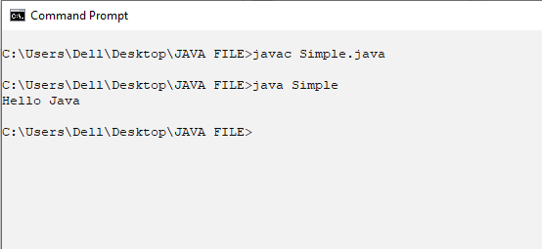

# Write program to display welcome to kcmit

## Source Code

class bim

{

public static void main(String[] args) {

System.out.println("welcome to kcmit");

}

}

## Output Window

